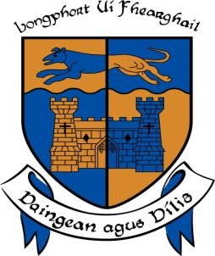

LONGFORD COUNTY COUNCIL

COMHAIRLE CHONTAE AN LONGFOIRT

Minutes of March Monthly Meeting of Longford County Council
held in the Council Chamber, Aras an Chontae, Great Water Street, Longford on
Wednesday, 9th March 2016 at 4.00 p.m.

_____________________________________________________________________

PRESIDING: Councillor Gerry Warnock, Cathaoirleach.

MEMBERS PRESENT: Councillors – Paraic Brady, John Browne,
Seamus Butler, Mick Cahill, Micheál Carrigy, Mark Casey John Duffy, Gerard Farrell, Padraig Loughrey Luie McEntire,
Martin Mulleady, Colm Murray, Peggy Nolan, Pat O’Toole,
P.J. Reilly, Paul Ross and Mae Sexton.

IN ATTENDANCE: Ms. Barbara Heslin, Acting Chief Executive.
Mr. John Brannigan, Director of Services.
Ms. Maeve Killian, Acting Head of Finance.
Mr. Ciaran Murphy, Acting Director of Services.

MEETINGS
ADMINISTRATOR: Ms. Anne Lee.

ADOPTION OF MINUTES.

On the proposal of Councillor M. Cahill seconded by Councillor C. Murray, the Minutes of Monthly Meeting of Longford County Council held on the 10th February 2016, as circulated, were confirmed and adopted.

MATTERS ARISING FROM MINUTES.

None.

CHIEF EXECUTIVE ORDERS.

The summary of Chief Executive Orders, as circulated, was noted.

MONTHLY MANAGEMENT REPORT.

The Monthly Management Report, as circulated, was noted.

Ms. B. Heslin, Acting Chief Executive, updated the meeting regarding the Regeneration Progamme and agreed to follow up on a suggestion from Councillor Mae Sexton that contact be made with the Region’s M.E.P.s regarding sourcing funding for the programme.

MINUTES OF CORPORATE POLICY GROUP MEETING.

The adopted minutes of Corporate Policy Group meeting held on the 13th January 2016 were noted.

FINANCE & INFORMATION SYSTEMS.

Public Liability Claims.

It was noted that five public liability claims were received during February 2016.

Councillor J. Browne referred to the condition of a manhole cover at Ard Aoibhinn, Longford. J. Brannigan to inspect and take appropriate action.

National Oversight & Audit Commission Report - Performance Indicators in Local Authorities 2014

The National Oversight & Audit Commission Report - Performance Indicators in Local Authorities 2014, as circulated, was noted.

HOUSING, INFRASTRUCTURE & EMERGENCY SERVICES.

National Oversight & Audit Commission Report – Local Authority Tenants’ Satisfaction Survey.

The National Oversight & Audit Commission Report – Local Authority Tenants’ Satisfaction Survey, as circulated, was noted.

ECONOMIC AND COMMUNITY DEVELOPMENT, PLANNING, HUMAN
RESOURCES & CORPORATE, CULTURAL & RECREATIONAL SERVICES.

Planning Applications.

The list of Planning Applications received since the last meeting of the Council was submitted and noted.

2015 Audit Committee Annual Report.

Mr. Patrick Groarke, Chairperson of the Audit Committee, outlined the details of the Annual Report of the Audit Committee under the following headings -

Section 1 - Background to Audit Committee.
Section 2 - Role & Functions of the Audit Committee.
Section 3 - Membership of the Audit Committee
Mr. Groarke referred to Denis Glennon joining the Committee on the
29th September 2015, filling the vacancy created by the untimely sad death of Gerry Brady on the 7th April. Mr. Groarke, on behalf of the Committee, expressed the sincere appreciation of the work done by Gerry during his short term as a member of the Audit Committee.
Section 4 - Chairpersons Statement.
Section 5 - Operation of the Audit Committee.
Section 6 - Going Forward.

Mr. Groarke referred to the issues raised by Ms. Anne Halion, Local Government Auditor, in the 2014 Statutory Audit Report regarding the Internal Audit function in the local authority, which he reported on at the January 2016 meeting of the Council.

Mr. Groarke stated that because the Council had not produced any internal audit reports in either 2014 or 2015, the Audit Committee could not carry out its statutory functions as set out in the Local Government Reform Act 2014. Mr. Groarke referred to correspondence which he forwarded to the Chief Executive and the Cathaoirleach regarding this issue.

Mr. Groarke confirmed that the Audit Committee is satisfied that the absence of internal audit function in the local authority is being rectified. Appropriate and necessary systems and programme of actions to address the internal audit function are being put in place.
B. Heslin updated the meeting regarding the staffing complement in the Internal Audit Section.

The Cathaoirleach and Acting Chief Executive thanked Mr. Groarke and the Audit Committee for their commitment to the Audit Committee.

On the proposal of Councillor S. Butler seconded by Councillor M. Cahill, it was unanimously agreed to adopt the 2015 Audit Committee Annual Report, as presented.

Community Tourism Initiative for the Diaspora.

Details of the Community Tourism Initiative for the Diaspora, as circulated, was noted.

The members of the media were requested to publicise this initiative - the closing date is the 21st March 2016.

GENERAL.

Update on Special Needs Assistants in St. Christopher’s National School.

Councillor P. O’Toole updated the members regarding the number of Special Needs Assistants in St. Christopher’s National School and referred to the march being organised by parents on Thursday, 10th March.

Correspondence – circulated.

Letter dated 26th February 2016 received from the Office of the Minister for Business and Employment regarding legislation surrounding zero hour contracts was noted.

A.O.B.

Meeting with H.S.E.

The members reiterated the need for a meeting to be held with representatives from the H.S.E. regarding health issues. Meetings Administrator to make contact again with the H.S.E.

Attic - Parkour Project.

On the proposal of Councillor S. Butler seconded by Councillor P. Nolan, it was unanimously agreed to transfer the approved funding of €10k to the Attic House from the Astra Turf project to the Parkour project, subject to the Department also agreeing to the change under their Sports Capital Grant.

General Election.

On the proposal of Councillor P. Brady seconded by Councillor M. Sexton, it was unanimously agreed that the County Registrar and Count Staff be complimented on the work carried out during the recent count. Congratulations was extended to the four successful candidates in the Longford/Westmeath constituency and also to Kate O’Connell who was elected in the Dublin Bay South Constituency, Kate’s family are from the Ballymahon area.

TRAINING –

Report from Corporate Policy Group was noted.

This concluded the business of the meeting.

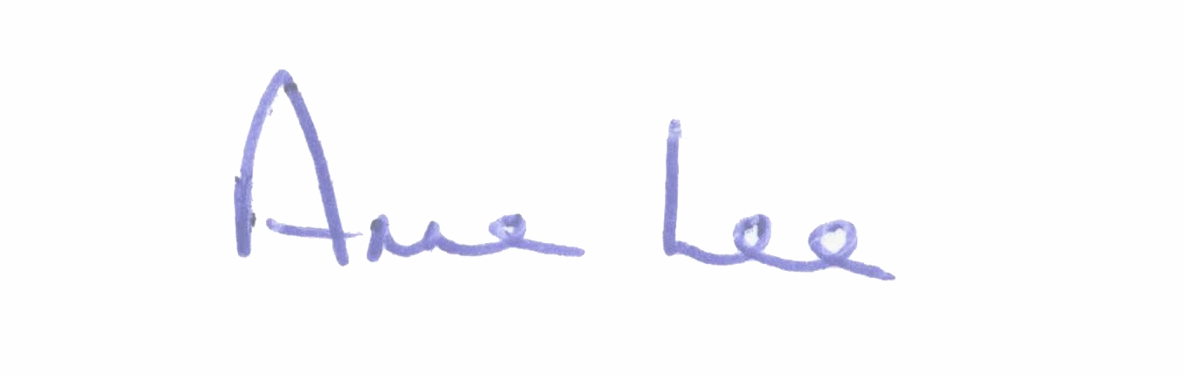

Signed: _______________
Anne Lee,
Meetings Administrator.

Confirmed and adopted at Monthly Meeting of Longford County Council held on
the 13th April 2016.

Signed: _______________
Cathaoirleach.

